## Convolution Neural Network

A Convolutional Neural Network (CNN) is a type of [Deep Learning neural network](https://www.geeksforgeeks.org/neural-networks-a-beginners-guide/) architecture commonly used in Computer Vision. Computer vision is a field of Artificial Intelligence that enables a computer to understand and interpret the image or visual data.

When it comes to Machine Learning, [Artificial Neural Networks](https://www.geeksforgeeks.org/artificial-neural-networks-and-its-applications/) perform really well. Neural Networks are used in various datasets like images, audio, and text. Different types of Neural Networks are used for different purposes, for example for predicting the sequence of words we use [Recurrent Neural Networks](https://www.geeksforgeeks.org/introduction-to-recurrent-neural-network/) more precisely an [LSTM](https://www.geeksforgeeks.org/understanding-of-lstm-networks/), similarly for image classification we use Convolution Neural networks.

Convolutional Neural Network (CNN) is the extended version of artificial neural networks (ANN) which is predominantly used to extract the feature from the grid-like matrix dataset. For example, visual datasets like images or videos where data patterns play an extensive role.

**CNN Architecture**

Convolutional Neural Network consists of multiple layers like the input layer, Convolutional layer, Pooling layer, and fully connected layers.

The **Convolutional layer** applies filters to the input image to extract features, the Pooling layer down samples the image to reduce computation, and the fully connected layer makes the final prediction. The network learns the optimal filters through backpropagation and gradient descent.

Now let’s talk about a bit of mathematics that is involved in the whole convolution process.

* Convolution layers consist of a set of learnable filters (or kernels) having small widths and heights and the same depth as that of input volume (3 if the input layer is image input).
* For example, if we must run convolution on an image with dimensions 34x34x3. The possible size of filters can be axax3, where ‘a’ can be anything like 3, 5, or 7 but smaller as compared to the image dimension.
* During the forward pass, we slide each filter across the whole input volume step by step where each step is called [stride](https://www.geeksforgeeks.org/ml-introduction-to-strided-convolutions/) (which can have a value of 2, 3, or even 4 for high-dimensional images) and compute the dot product between the kernel weights and patch from input volume.
* As we slide our filters, we’ll get a 2-D output for each filter and we’ll stack them together as a result, we’ll get output volume having a depth equal to the number of filters. The network will learn all the filters.

**Layers Used to Build ConvNets**

A complete Convolution Neural Networks architecture is also known as covnets. A covnets is a sequence of layers, and every layer transforms one volume to another through a differentiable function.   
Let’s take an example by running a covnets on of image of dimension 32 x 32 x 3.

* Input Layers: It’s the layer in which we give input to our model. In CNN, Generally, the input will be an image or a sequence of images. This layer holds the raw input of the image with width 32, height 32, and depth 3.
* Convolutional Layers: This is the layer, which is used to extract the feature from the input dataset. It applies a set of learnable filters known as the kernels to the input images. The filters/kernels are smaller matrices usually 2×2, 3×3, or 5×5 shape. it slides over the input image data and computes the dot product between kernel weight and the corresponding input image patch. The output of this layer is referred as feature maps. Suppose we use a total of 12 filters for this layer we’ll get an output volume of dimension 32 x 32 x 12.
* [Activation Layer:](https://www.geeksforgeeks.org/activation-functions-neural-networks/)By adding an activation function to the output of the preceding layer, activation layers add nonlinearity to the network. it will apply an element-wise activation function to the output of the convolution layer. Some common activation functions are RELU: max(0, x),  Tanh, Leaky RELU, etc. The volume remains unchanged hence output volume will have dimensions 32 x 32 x 12.
* [Pooling layer:](https://www.geeksforgeeks.org/cnn-introduction-to-pooling-layer/) This layer is periodically inserted in the covnets and its main function is to reduce the size of volume which makes the computation fast reduces memory and also prevents overfitting. Two common types of pooling layers are max pooling and average pooling. If we use a max pool with 2 x 2 filters and stride 2, the resultant volume will be of dimension 16x16x12.

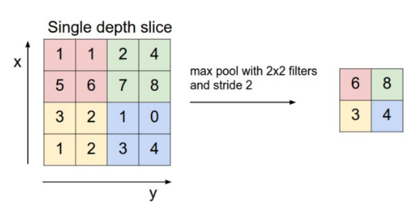

* **Flattening:**The resulting feature maps are flattened into a one-dimensional vector after the convolution and pooling layers so they can be passed into a completely linked layer for categorization or regression.
* **Fully Connected Layers:**It takes the input from the previous layer and computes the final classification or regression task.

